SYSC 5104 Assignment 1

Glenn Davidson

101205195

A DEVS computer system model was attempted and was completed as a subset of the initial specification. The goal of the system was to investigate processing delay vs arriving tasks in a simple manner, while supporting the potential for expansion of the model to accommodate more complex scheduling algorithms. The system was implemented with first come first served scheduling with no task pre-emption.

**Part I – Initial Model Specification**

A DEVS computer system model will be developed to investigate the processing delay in a first come first served single processor system. The model will consist of a simple operating system, a processor, and a system clock. The operating system will log the submission time of new tasks, forward tasks to the processor, accept completion notifications from the processor, and output tasks processing time. The execution of the operating system itself will not be modeled, and will behave as if acting much faster than the processor model completes tasks. Modeling the operating system in this way will hopefully reduce the number of events occurring at the same time at clock events. Also ignored in this model are: task blocking (due to input/output and interrupts), memory access, task pre-emption, and system errors.

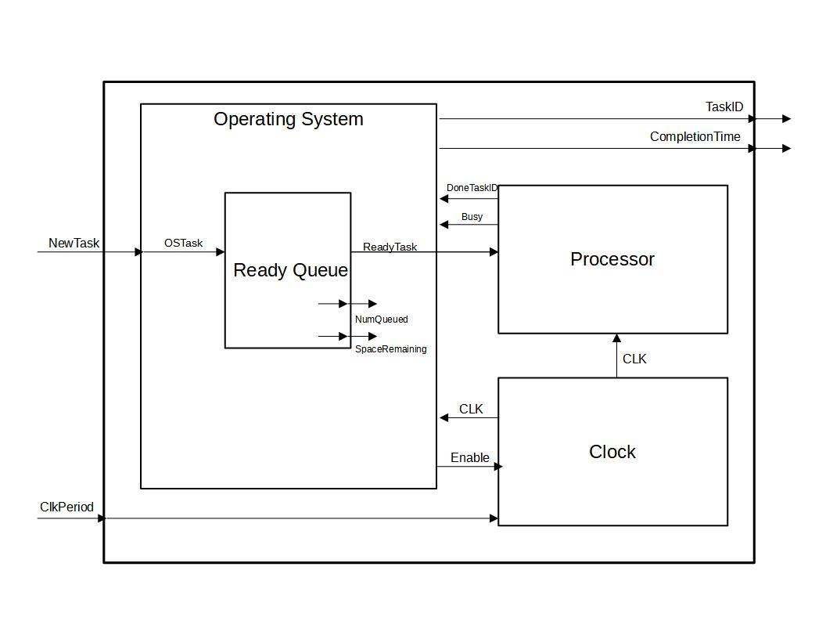

**Figure #1: Basic Computer System Diagram**

**Clock:**

The clock model will serve as a the logical clock for the processor. It will accept a clock period input, and an enable signal, and will output a 50% duty cycle square wave with the specified clock period if the clock is enabled. If the clock is disabled, it will output logic zero until it becomes enabled again. The state of the clock can be described as Enabled/Disabled, with state variables ClockPeriod, ClockLevel, EnableInput, and elapsed time. The clock may receive an Enable/Disable signal at any time.

**Processor:**

The processor model emulates the computation of tasks given to it, at a speed determined by the Clock input it accepts. Its inputs are consist of a task to compute and a digital clock signal. The processor will compute one task at a time, and will complete one work unit of its assigned task every clock cycle. A task in this system consists of an integer identifier, and a count of the number of work units required to compete it. The processor may receive a task at any time, but will ignore any input tasks if it is busy. When the processor finishes a task, it will output the completed task’s ID. The states of the processor model include Idle, Busy, and DoneTask.

**Operating System:**

The operating system model accepts new tasks input to it, places them in a queue, and schedules them to run on a processor model if the processor indicates that it is free. The operating system receives a processor busy signal when a task is already running on the processor, and receives a task ID from the processor when a task is completed. The operating system logs the submission time of each task when received, and notes the time again when it receives the indication the specific task has been competed. Upon completion of a task, the Operating System outputs the task’s ID, together with the total time that has passed since the task was submitted to the operating system. The ready queue will be implemented as an atomic model which the Operating System will use. When no tasks are in the queue and the processor is idle, the operating system will disable the clock.

**Ready Queue:**

The ready queue will store tasks given by the operating system, and will output a task when requested by the operating system in a first in, first out order. The queue will indicate to the operating system how many tasks are stored within, as well as how much space is left within the queue.

If the above is not easily achieved, the processor may output completed task IDs to the outside world, instead of the operating system computing the processing delay and outputting this with a task ID. If the above is easily achieved, the processor and operating system may be modified to implement round robin scheduling with a static time quantum, where pre-empted tasks are placed in the rear of the ready queue.

**Part II – Formal Specifications and Testing**

The model described in part I can be divided into two separate coupled models that will work together to form the top model of the Computer System. The two coupled models will be defined as Operating System (OS) and Hardware. The operating system will be composed to a queue atomic model and a task scheduling atomic model that will control the queue. The hardware will consist of a Clock atomic model that mimics a digital logic clock, and a Processor atomic model that executes the tasks given to it.

The OS and Hardware models will be coupled with a task message port, a processor busy port, and an enable port, where the OS will send an enable signal and ready tasks to hardware if the OS have a task queued. Diagrams of the coupled models can be seen in the images below. The top model accepts tasks to be queued by the OS, and outputs completed tasks which can be identified by their ID. The proposed top model, and two coupled models can be seen in Figures #2-4.

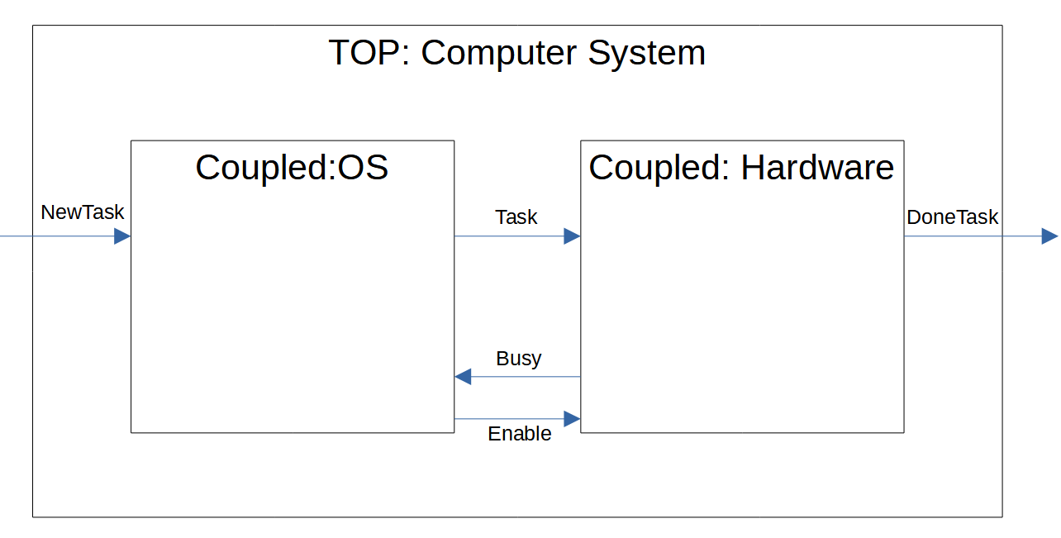

**Figure #2: Top Model Diagram**

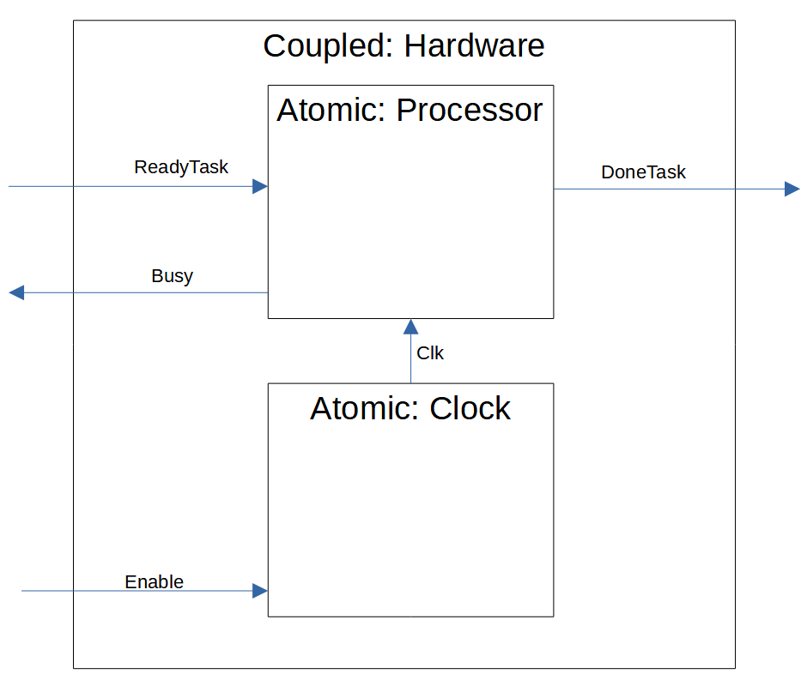

**Figure #3: Coupled Hardware Diagram**

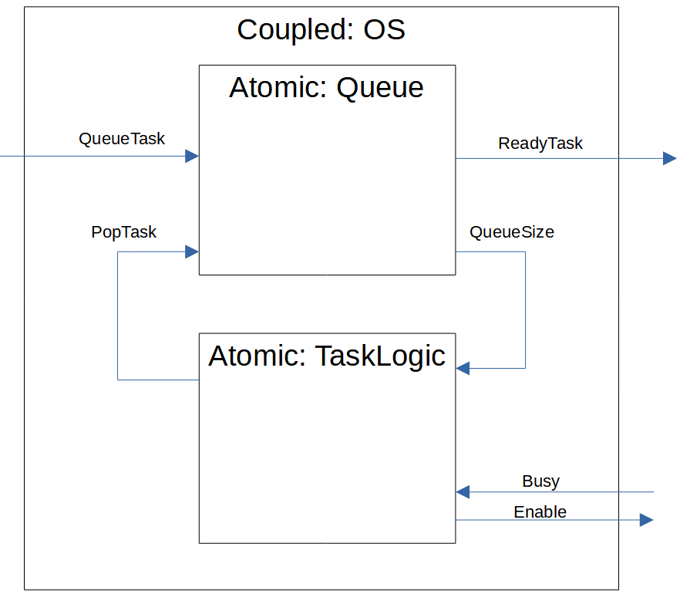

**Figure #4: Coupled Hardware Diagram**

**Hardware Coupled Model Formal Specification:**

**Inputs:**

* ReadyTask – A task ready to be executed by the processor, consists of a task id and the number of clock cycles it will take to complete
* Enable – A signal that enables and disables the digital clock

**Outputs:**

* DoneTask – A task that is evicted from the processor, consisting of a task id and remaining clock cycles to complete. In this model all tasks will run to completion and will therefore always output 0 for the number of clock cycles required to complete.
* Busy – a signal that indicates whether the processor is ready to accept a new task or not

**Model Indexes:** Processor is D[0], Clock is D[1]

**Models:** M[0] is atomic processor model, M[1] is atomic clock model

**Internal Couplings:** Clk

**Influences:** Clock model influences processor model, processor model does not influence clock model

**Select:** The enable input should have priority over the ReadyTask input

The Donetask output should have priority over the busy signal

**OS Coupled Model Formal Specification:**

**Inputs:**

* QueueTask – A new task arriving from outside the system
* Busy – An indication of whether the hardware can accept a new task to process

**Outputs:**

* ReadyTask – A task that in transit to the hardware to be executed
* Enable – A signal that will enable or disable the Hardware model

**Model Indexes:** Queue is D[0], Logic is D[1]

**Models:** M[0] is atomic Queue model, M[1] is atomic TaskLogic model

**Internal Couplings:**

* QueueSize – Reports the size of queue to logic
* PopTask – A command input to the queue to signal that it should send a ready task

**Influences**: Queue model influences TaskLogic model, and the TaskLogic model influences the Queue model

**Select:** The enable input should have priority over the ReadyTask input

The Donetask output should have priority over the busy signal

**Atomic Clock Specification:**

**X:** Enable (bool)

**Y:** ClkLevel (bool) – where value true represents “clock high” and false represents “clock low”

**S:** IsEnabled, CurrentLevel (bool, bool)

**δext:**

* If the state IsEnabled is true, and a false input is received, then set the state IsEnabled to false, and set the ClkLevel to “clock low”
* If the state IsEnabled is false, and a true input is received, then set the state IsEnabled to false, and set the ClkLevel to “clock high”

**δint:**

* If clock is high, then set the level to low
* If the clock is low, then set the level to high

**λ:** ClkLevel output gets the value of the state variable CurrentLevel

t**a(s):**

* if IsEnabled == true then T = ClockPeriod/2
* else T = inf

**Atomic Clock Test:**

The goal of the atomic clock test case is to observe the enable and disable of the clock at time. The clock should have its first rising edge half of a clock period after becoming enabled. The clock level should fall to low immediately upon disable. In this project, a high clock level corresponds to the value true, and low corresponds to value false. The clock period is arbitrarily set to 1s. This is not a realistic value but is sufficient to verify the operation of the model. The time structure NDTime used to create this model has precision down to 1ms. A time resolution down in the range of nano seconds would have been more appropriate.

**Atomic Processor Specification:**

**X:** NewTask (TaskMessage), Clk (bool)

**Y:** Busy (bool), DoneTask (TaskMessage)

**S:** CurrentTask (TaskMessage), InternalState (enum) = {“idle”, “begin”, “processing”, “output”}

**δext:**

* If the input is NewTask and InternalState is “idle” then set the CurrentTask to be the input NewTask and set InternalState to “begin”
* If Clock input and InternalState is “processing” and Clk is “high” (true), and TaskMessage has more than one cycle before completion, then decrement the number of cycles remaining in the TaskMessage.
* If Clock input and InternalState is “processing” and Clk is “high” (true) and TaskMessage has exaclty one cycle before completion, then decrement the number of cycles remaining and change InternalState to “output”
* In all other cases, ignore new tasks arriving or clock edges

**δint:**

* If InternalState is “begin”, set state to “busy”
* If InternalState is “output”, set state to “idle” and set the CurrentTask.ID and CurrentTask.Cycles remaining to 0.

**λ:**

* If InternalState is “begin” then output Busy = true
* If InternalState is “output” then output Busy = false, and output DoneTask = CurrentTask

t**a(s):**

// case start new task – output busy and advance to processing

{ if InternalState == “begin” -> T = 0 }

// case advance to next clock edge (perform one work unit)

{ if InternalState == “processing” -> T = inf }

// case need to output a Task

{ if InternalState == “output” -> T = 0 }

// case idle

{ if InternalState == “idle” -> T = inf}

**Atomic Processor Testing:**

The processor should be seen to do nothing if no clock transitions are present on its input. The test case should begin in an idle state, and input a clock signal after being idle for some time. While the processor is idle, a busy = false should be observed every clock cycle.

A task should be presented to the input of the processor and in response the processor should indicate that it is working on the task through its busy= true. This first task will run to completion, and the processor should be observed to become idle.

Next the processor should be given consecutive tasks and should be observed to start one task while outputting a completed task at the same time. The processor will become idle and output busy = false every clock cycle. Next the processor should be observed to ignore incoming tasks while it is busy processing a task.

**Atomic** **Queue Specification:**

**X:** NewTask, TaskRequest = TaskMessage_t, bool

**Y:** OutTask, QueueSize = TaskMessage_t, int

**S:** QueueState, TaskQueue = enum, queue<TaskMessage_t>

QueueState enum = {“waiting”, “pushtask”,“poptask”, “requested”}

**del_ext:**

{if QueueState == “waiting” && X:NewTask && NumWaiting < MaxSize

-> QueueState = “pushtask”; QueueStructure.pushback(NewTask)}

{if QueueState == “waiting} && X: TaskRequest == true && NumWaiting == 0}

-> QueueState = “requested”

{if QueueState == “waiting” && X: TaskRequest == true && NumWaiting > 0

-> QueueState = “poptask”}

{if QueueState == “requested” &&: X:NewTask}

-> init Queue and then QueueState = “poptask”

**del_int:**

**//** case update the queue size only

if(QueueState == “pushtask”)

-> QueueState = “waiting”

**//** case output a task from the queue

{if QueueState == “poptask”

-> queue.pop(); QueueState = “waiting”}

**lamda:**

**//** output new queue size only

{ if QueueState == “pushtask” -> Queuesize = queue.size()

**//** case output the next task in the queue and the new queue size

{if QueueState == “poptask” -> OutTask = Next; Queuesize = queue.size() -1}

t**a(s):**

if QueueState == “pushtask” -> T = 0

if QueueState == “poptask” -> T = 0

if QueueState == “waiting” -> T = inf

if QueueState == “requested” -> T = inf

**Atomic Queue Testing:**

The goals of the atomic queue tests are to observe that an item can arrive and become queued at any time. It should also be observed that the queue can store up to a specified maximum number of items, and ignores any items sent to its input while it is full. It should also be observed that the queue offers no response if it is empty and it receives a request to pop an item out of the queue. No time delay should be observed when popping an item from the queue either.

**Atomic TaskLogic Specification:**

**X:** Busy (bool), QueueSize (int)

**Y:** Enable (bool), PopTask (bool)

**S:** QueueSizeZero (bool), TaskRequested (bool), InternalState (enum)

InternalState = {“disabled_system”, “waiting_qb”, “waiting_q”, “waiting_b”, “popping”}

* “disabled_system” – The OS has not enabled the Hardware to run
* “waiting_qb” – Waiting for a not busy signal from hardware and a queue size greater than zero
* “waiting_q” – A not busy signal has been received by Hardware but the queue size is zero
* “waiting_b” – The queue size is not zero but a not busy signal has not yet been received from Hardware
* “popping” – The TaskLogic has deduced that the Hardware is not busy and the queue is not empty and will output a pop command to the Queue

**δext:**

If QueueSize input then update the internal state variable QueueSizeZero

Only set to true if the queue size is zero

If Busy input then update the internal state variableTaskRequested

Set to true only is a Busy = false input is received.

**δint:**

If InternalState is “disabled_system” then set InternalState to “waiting_qb”

If InternalState is “popping” then set InternalState to “waiting_qb” or “waiting_b” depending on queuesize

**λ:**

if InternalState is “disabled_system” then output Enable = true

if InternalState is “popping” then output PopTask = true

t**a(s):**

if InternalState is “disabled_system” then T = StartUpDelay

if InternalState is “waiting_qb” then T = inf

if InternalState is “waiting_q” then T = inf

if InternalState is “waiting_b” then T = inf

if InternalState is “popping” then T = ProcessingDelay

**Atomic TaskLogic Test Cases:**

In the proposed tests, the queue size will be initialized to zero, and the StartUpDelay will be set to 9 seconds. ProcessingDelay will be 10ms. The tests will be described as a sequence of events upon entering the “waiting_bq” state after being in “disabled_system”:

Case 1:

TaskLogic enables Hardware at global time of 9s

The queue size increases to 3

The processor then sends a Busy = false input

TaskLogic Enters “popping”, outputs a pop command after 10ms

Task logic enters “waiting_b”

Case 2:

TaskLogic enables Hardware at global time of 9s

TaskLogic recives a Busy = false input but the queue size is 0.

TaskLogic receives an indication that the Queue Size has become 1.

TaskLogic Enters “popping”, outputs a pop command after 10ms

Task logic enters “waiting_bq”

It is especially important to test that in the condition that the queue size is zero when the processor sends a not busy signal, the TaskLogic remembers that not busy was sent when items finally do arrive in the queue, but still must also check that the processor is still not busy. A not busy signal should only ever be sent once.

**Part III – Model Implementation**

The model specified in part II described the system as two coupled models within one top model. For the purposes of completing the assignment faster, the TaskLogic atomic model was not implemented, and the Operating System coupled model was simplified to consist only of the queue structure. The Hardware coupled model was modified to accommodate this change, and now sends a Boolean not busy every clock cycle if the processor is in the idle state. In this way, the Queue structure is driven by the Hardware model alone. The Hardware coupled model and the queue structure were placed in a top model and were shown to operate as expected.

Each of the three atomic models in this project has their own test program and test input to verify their correctness. The top model also has a test input to verify its correctness. This section of the report will review the results of these tests. The readme.txt file in the parent directory of the project will describe how to compile the tests described below, and where the results of these tests can be found.

**Clock Atomic Model Results:**

The clock model test can be run through the CLOCK_TEST executable in the bin folder of the project. The test input for the clock atomic model is as follows:

* Begin idle
* Enable at 00:00:09:500 input {true}
* at 00:00:10:000 observe ClkLevel = true
* at 00:00:10:500 observe ClkLevel = false
* at 00:00:11:000 observe ClkLevel = true
* at 00:00:11:500 observe ClkLevel = false
* at 00:00:12:000 observe ClkLevel = true
* Disable mid cycle 00:00:12:100 input {false} observe ClkLevel = false
* Enable again at 00:00:19:500 and watch continual run
* Disable at on a rising clock edge 00:00:22:00 observe ClkLevel = false

When given input data as described above, the model behaves as expected. The input data and output logs can be seen to be:

**clock_input_test.txt**

00:00:09:500 1

00:00:12:100 0

00:00:19:500 1

00:00:22:000 0

**clock_test_output_state.txt**

00:00:00:000

State for model input_reader is next time: 00:00:00:000

State for model clock1 is clk_high: 0 & clk_enabled: 0

00:00:00:000

State for model input_reader is next time: 00:00:09:500

State for model clock1 is clk_high: 0 & clk_enabled: 0

00:00:09:500

State for model input_reader is next time: 00:00:02:600

State for model clock1 is clk_high: 1 & clk_enabled: 1

00:00:10:000

State for model input_reader is next time: 00:00:02:600

State for model clock1 is clk_high: 0 & clk_enabled: 1

00:00:10:500

State for model input_reader is next time: 00:00:02:600

State for model clock1 is clk_high: 1 & clk_enabled: 1

00:00:11:000

State for model input_reader is next time: 00:00:02:600

State for model clock1 is clk_high: 0 & clk_enabled: 1

00:00:11:500

State for model input_reader is next time: 00:00:02:600

State for model clock1 is clk_high: 1 & clk_enabled: 1

00:00:12:000

State for model input_reader is next time: 00:00:02:600

State for model clock1 is clk_high: 0 & clk_enabled: 1

00:00:12:100

State for model input_reader is next time: 00:00:07:900

State for model clock1 is clk_high: 0 & clk_enabled: 0

00:00:20:000

State for model input_reader is next time: 00:00:02:000

State for model clock1 is clk_high: 1 & clk_enabled: 1

00:00:20:500

State for model input_reader is next time: 00:00:02:000

State for model clock1 is clk_high: 0 & clk_enabled: 1

00:00:21:000

State for model input_reader is next time: 00:00:02:000

State for model clock1 is clk_high: 1 & clk_enabled: 1

00:00:21:500

State for model input_reader is next time: 00:00:02:000

State for model clock1 is clk_high: 0 & clk_enabled: 1

00:00:22:000

State for model input_reader is next time: inf

State for model clock1 is clk_high: 0 & clk_enabled: 0

**clock_test_output_messages.txt**

00:00:00:000

00:00:00:000

[cadmium::basic_models::pdevs::iestream_input_defs<bool>::out: {}] generated by model input_reader

00:00:09:500

[cadmium::basic_models::pdevs::iestream_input_defs<bool>::out: {1}] generated by model input_reader

00:00:10:000

[Clock_defs::out: {1}] generated by model clock1

00:00:10:500

[Clock_defs::out: {0}] generated by model clock1

00:00:11:000

[Clock_defs::out: {1}] generated by model clock1

00:00:11:500

[Clock_defs::out: {0}] generated by model clock1

00:00:12:000

[Clock_defs::out: {1}] generated by model clock1

00:00:12:100

[cadmium::basic_models::pdevs::iestream_input_defs<bool>::out: {0}] generated by model input_reader

00:00:20:000

[cadmium::basic_models::pdevs::iestream_input_defs<bool>::out: {1}] generated by model input_reader

00:00:20:500

[Clock_defs::out: {1}] generated by model clock1

00:00:21:000

[Clock_defs::out: {0}] generated by model clock1

00:00:21:500

[Clock_defs::out: {1}] generated by model clock1

00:00:22:000

[cadmium::basic_models::pdevs::iestream_input_defs<bool>::out: {0}] generated by model input_reader

[Clock_defs::out: {0}] generated by model clock1

**Atomic Processor Results:**

The processor test input it split between two files, a clock input and a task input. The processor test can be run through the PROCESSOR_TEST executable in the bin folder of the project. The input test files specify this test as follows:

The clock will run starting at 10s and will run until 20s, with the first rising edge at 10s, and the last rising edge at 20s.

The tasks come in the form of a task message data structure which contains two elements, a task id, and the number of clock cycles that it will take for the processor to complete the task, and is read with an input reader in the form {task_id work_units}. The arriving tasks to the system for the processor test are:

**processor_task_input_test.txt**

00:00:11:900 1001 3

00:00:14:600 1002 2

00:00:15:100 1003 5

00:00:16:000 1004 3

Task 1001 will run to completion, finishing at t=14s. Task 1002 will begin computing at t=15s, and finish at 17s, while task 1003 will begin at 17s. Task 1004 arriving at 17.1s will be ignored by the processor. The processor model can be seen to be doing work on tasks every cycle when it is busy in the output_state log file. Note that the processor decrements the TaskMessage_t.work_units field, and could theoretically be evicted from the processor and placed back in a queue before completed in a more advanced version of this project.

**processor_test_output_state.txt**

00:00:00:000

State for model input_reader_newtask is next time: 00:00:00:000

State for model input_reader_clk is next time: 00:00:00:000

State for model processor1 is state: idle Current Task: 0 0 Idle Count: 0

00:00:00:000

State for model input_reader_newtask is next time: 00:00:11:900

State for model input_reader_clk is next time: 00:00:10:000

State for model processor1 is state: idle Current Task: 0 0 Idle Count: 0

00:00:10:000

State for model input_reader_newtask is next time: 00:00:11:900

State for model input_reader_clk is next time: 00:00:00:500

State for model processor1 is state: done Current Task: 0 0 Idle Count: 1

00:00:10:000

State for model input_reader_newtask is next time: 00:00:11:900

State for model input_reader_clk is next time: 00:00:00:500

State for model processor1 is state: idle Current Task: 0 0 Idle Count: 0

00:00:10:500

State for model input_reader_newtask is next time: 00:00:11:900

State for model input_reader_clk is next time: 00:00:00:500

State for model processor1 is state: idle Current Task: 0 0 Idle Count: 0

00:00:11:000

State for model input_reader_newtask is next time: 00:00:11:900

State for model input_reader_clk is next time: 00:00:00:500

State for model processor1 is state: done Current Task: 0 0 Idle Count: 1

00:00:11:000

State for model input_reader_newtask is next time: 00:00:11:900

State for model input_reader_clk is next time: 00:00:00:500

State for model processor1 is state: idle Current Task: 0 0 Idle Count: 0

00:00:11:500

State for model input_reader_newtask is next time: 00:00:11:900

State for model input_reader_clk is next time: 00:00:00:500

State for model processor1 is state: idle Current Task: 0 0 Idle Count: 0

00:00:11:900

State for model input_reader_newtask is next time: 00:00:02:700

State for model input_reader_clk is next time: 00:00:00:500

State for model processor1 is state: begin Current Task: 1001 3 Idle Count: 0

00:00:11:900

State for model input_reader_newtask is next time: 00:00:02:700

State for model input_reader_clk is next time: 00:00:00:500

State for model processor1 is state: busy Current Task: 1001 3 Idle Count: 0

00:00:12:000

State for model input_reader_newtask is next time: 00:00:02:700

State for model input_reader_clk is next time: 00:00:00:500

State for model processor1 is state: busy Current Task: 1001 2 Idle Count: 0

00:00:12:500

State for model input_reader_newtask is next time: 00:00:02:700

State for model input_reader_clk is next time: 00:00:00:500

State for model processor1 is state: busy Current Task: 1001 2 Idle Count: 0

00:00:13:000

State for model input_reader_newtask is next time: 00:00:02:700

State for model input_reader_clk is next time: 00:00:00:500

State for model processor1 is state: busy Current Task: 1001 1 Idle Count: 0

00:00:13:500

State for model input_reader_newtask is next time: 00:00:02:700

State for model input_reader_clk is next time: 00:00:00:500

State for model processor1 is state: busy Current Task: 1001 1 Idle Count: 0

00:00:14:000

State for model input_reader_newtask is next time: 00:00:02:700

State for model input_reader_clk is next time: 00:00:00:500

State for model processor1 is state: done Current Task: 1001 0 Idle Count: 0

00:00:14:000

State for model input_reader_newtask is next time: 00:00:02:700

State for model input_reader_clk is next time: 00:00:00:500

State for model processor1 is state: idle Current Task: 0 0 Idle Count: 0

00:00:14:500

State for model input_reader_newtask is next time: 00:00:02:700

State for model input_reader_clk is next time: 00:00:00:500

State for model processor1 is state: idle Current Task: 0 0 Idle Count: 0

00:00:14:600

State for model input_reader_newtask is next time: 00:00:00:500

State for model input_reader_clk is next time: 00:00:00:500

State for model processor1 is state: begin Current Task: 1002 2 Idle Count: 0

00:00:14:600

State for model input_reader_newtask is next time: 00:00:00:500

State for model input_reader_clk is next time: 00:00:00:500

State for model processor1 is state: busy Current Task: 1002 2 Idle Count: 0

00:00:15:000

State for model input_reader_newtask is next time: 00:00:00:500

State for model input_reader_clk is next time: 00:00:00:500

State for model processor1 is state: busy Current Task: 1002 1 Idle Count: 0

00:00:15:100

State for model input_reader_newtask is next time: 00:00:00:900

State for model input_reader_clk is next time: 00:00:00:500

State for model processor1 is state: busy Current Task: 1002 1 Idle Count: 0

00:00:15:500

State for model input_reader_newtask is next time: 00:00:00:900

State for model input_reader_clk is next time: 00:00:00:500

State for model processor1 is state: busy Current Task: 1002 1 Idle Count: 0

00:00:16:000

State for model input_reader_newtask is next time: inf

State for model input_reader_clk is next time: 00:00:00:500

State for model processor1 is state: done Current Task: 1002 0 Idle Count: 0

00:00:16:000

State for model input_reader_newtask is next time: inf

State for model input_reader_clk is next time: 00:00:00:500

State for model processor1 is state: idle Current Task: 0 0 Idle Count: 0

00:00:16:500

State for model input_reader_newtask is next time: inf

State for model input_reader_clk is next time: 00:00:00:500

State for model processor1 is state: idle Current Task: 0 0 Idle Count: 0

00:00:17:000

State for model input_reader_newtask is next time: inf

State for model input_reader_clk is next time: 00:00:00:500

State for model processor1 is state: done Current Task: 0 0 Idle Count: 1

00:00:17:000

State for model input_reader_newtask is next time: inf

State for model input_reader_clk is next time: 00:00:00:500

State for model processor1 is state: idle Current Task: 0 0 Idle Count: 0

00:00:17:500

State for model input_reader_newtask is next time: inf

State for model input_reader_clk is next time: 00:00:00:500

State for model processor1 is state: idle Current Task: 0 0 Idle Count: 0

00:00:18:000

State for model input_reader_newtask is next time: inf

State for model input_reader_clk is next time: 00:00:00:500

State for model processor1 is state: done Current Task: 0 0 Idle Count: 1

00:00:18:000

State for model input_reader_newtask is next time: inf

State for model input_reader_clk is next time: 00:00:00:500

State for model processor1 is state: idle Current Task: 0 0 Idle Count: 0

00:00:18:500

State for model input_reader_newtask is next time: inf

State for model input_reader_clk is next time: 00:00:00:500

State for model processor1 is state: idle Current Task: 0 0 Idle Count: 0

00:00:19:000

State for model input_reader_newtask is next time: inf

State for model input_reader_clk is next time: 00:00:00:500

State for model processor1 is state: done Current Task: 0 0 Idle Count: 1

00:00:19:000

State for model input_reader_newtask is next time: inf

State for model input_reader_clk is next time: 00:00:00:500

State for model processor1 is state: idle Current Task: 0 0 Idle Count: 0

00:00:19:500

State for model input_reader_newtask is next time: inf

State for model input_reader_clk is next time: 00:00:00:500

State for model processor1 is state: idle Current Task: 0 0 Idle Count: 0

00:00:20:000

State for model input_reader_newtask is next time: inf

State for model input_reader_clk is next time: 00:00:00:500

State for model processor1 is state: done Current Task: 0 0 Idle Count: 1

00:00:20:000

State for model input_reader_newtask is next time: inf

State for model input_reader_clk is next time: 00:00:00:500

State for model processor1 is state: idle Current Task: 0 0 Idle Count: 0

00:00:20:500

State for model input_reader_newtask is next time: inf

State for model input_reader_clk is next time: inf

State for model processor1 is state: idle Current Task: 0 0 Idle Count: 0

**Queue Atomic Model Results:**

The queue test input is split between two files, one that specifies the arrival of new tasks to the queue, and another that specifies when the queue should pop a task out. The queue test can be run through the QUEUE_TEST executable in the bin folder of the project. Note that the Queue’s bool input called givetask, that controls when a task is to be popped, uses a logic level false to indicate that it should pop. This does contradict the naming somewhat, but was changed so that a processor not busy signal will pop the queue. The arrival of tasks in the queue test are:

**queue_givetask_input_test.txt**

00:00:10 1 10

00:00:11 2 20

00:00:12 3 30

00:00:14 4 40

00:00:15 5 50

00:00:19 6 45

Where the two numbers after the time are a task message {task_id work_units}. The popping of tasks from the queue are are follows:

**queue_newtask_input_test.txt**

00:00:16 0

00:00:17 0

00:00:18 0

00:00:20 0

00:00:21 0

00:00:22 0

The task arriving at 15s (id = 5) will not become queued because the maximum queue size was chosen arbitrarily to be 4. A pop signal is also sent to an empty queue a t = 22s and no response is given.

**The state log for this test is:**

00:00:00:000

State for model input_reader_newtask is next time: 00:00:00:000

State for model input_reader_givetask is next time: 00:00:00:000

State for model fifo_queue1 is state: WAITING & queue size: 0

QUEUE DATA:

00:00:00:000

State for model input_reader_newtask is next time: 00:00:10:000

State for model input_reader_givetask is next time: 00:00:16:000

State for model fifo_queue1 is state: WAITING & queue size: 0

QUEUE DATA:

00:00:10:000

State for model input_reader_newtask is next time: 00:00:01:000

State for model input_reader_givetask is next time: 00:00:16:000

State for model fifo_queue1 is state: PUSHTASK & queue size: 1

QUEUE DATA: 1 10

00:00:10:000

State for model input_reader_newtask is next time: 00:00:01:000

State for model input_reader_givetask is next time: 00:00:16:000

State for model fifo_queue1 is state: WAITING & queue size: 1

QUEUE DATA: 1 10

00:00:11:000

State for model input_reader_newtask is next time: 00:00:01:000

State for model input_reader_givetask is next time: 00:00:16:000

State for model fifo_queue1 is state: PUSHTASK & queue size: 2

QUEUE DATA: 1 10 2 20

00:00:11:000

State for model input_reader_newtask is next time: 00:00:01:000

State for model input_reader_givetask is next time: 00:00:16:000

State for model fifo_queue1 is state: WAITING & queue size: 2

QUEUE DATA: 1 10 2 20

00:00:12:000

State for model input_reader_newtask is next time: 00:00:02:000

State for model input_reader_givetask is next time: 00:00:16:000

State for model fifo_queue1 is state: PUSHTASK & queue size: 3

QUEUE DATA: 1 10 2 20 3 30

00:00:12:000

State for model input_reader_newtask is next time: 00:00:02:000

State for model input_reader_givetask is next time: 00:00:16:000

State for model fifo_queue1 is state: WAITING & queue size: 3

QUEUE DATA: 1 10 2 20 3 30

00:00:14:000

State for model input_reader_newtask is next time: 00:00:01:000

State for model input_reader_givetask is next time: 00:00:16:000

State for model fifo_queue1 is state: PUSHTASK & queue size: 4

QUEUE DATA: 1 10 2 20 3 30 4 40

00:00:14:000

State for model input_reader_newtask is next time: 00:00:01:000

State for model input_reader_givetask is next time: 00:00:16:000

State for model fifo_queue1 is state: WAITING & queue size: 4

QUEUE DATA: 1 10 2 20 3 30 4 40

00:00:15:000

State for model input_reader_newtask is next time: 00:00:04:000

State for model input_reader_givetask is next time: 00:00:16:000

State for model fifo_queue1 is state: WAITING & queue size: 4

QUEUE DATA: 1 10 2 20 3 30 4 40

00:00:16:000

State for model input_reader_newtask is next time: 00:00:04:000

State for model input_reader_givetask is next time: 00:00:01:000

State for model fifo_queue1 is state: POPTASK & queue size: 3

QUEUE DATA: 2 20 3 30 4 40

00:00:16:000

State for model input_reader_newtask is next time: 00:00:04:000

State for model input_reader_givetask is next time: 00:00:01:000

State for model fifo_queue1 is state: WAITING & queue size: 3

QUEUE DATA: 2 20 3 30 4 40

00:00:17:000

State for model input_reader_newtask is next time: 00:00:04:000

State for model input_reader_givetask is next time: 00:00:01:000

State for model fifo_queue1 is state: POPTASK & queue size: 2

QUEUE DATA: 3 30 4 40

00:00:17:000

State for model input_reader_newtask is next time: 00:00:04:000

State for model input_reader_givetask is next time: 00:00:01:000

State for model fifo_queue1 is state: WAITING & queue size: 2

QUEUE DATA: 3 30 4 40

00:00:18:000

State for model input_reader_newtask is next time: 00:00:04:000

State for model input_reader_givetask is next time: 00:00:02:000

State for model fifo_queue1 is state: POPTASK & queue size: 1

QUEUE DATA: 4 40

00:00:18:000

State for model input_reader_newtask is next time: 00:00:04:000

State for model input_reader_givetask is next time: 00:00:02:000

State for model fifo_queue1 is state: WAITING & queue size: 1

QUEUE DATA: 4 40

00:00:19:000

State for model input_reader_newtask is next time: inf

State for model input_reader_givetask is next time: 00:00:02:000

State for model fifo_queue1 is state: PUSHTASK & queue size: 2

QUEUE DATA: 4 40 6 45

00:00:19:000

State for model input_reader_newtask is next time: inf

State for model input_reader_givetask is next time: 00:00:02:000

State for model fifo_queue1 is state: WAITING & queue size: 2

QUEUE DATA: 4 40 6 45

00:00:20:000

State for model input_reader_newtask is next time: inf

State for model input_reader_givetask is next time: 00:00:01:000

State for model fifo_queue1 is state: POPTASK & queue size: 1

QUEUE DATA: 6 45

00:00:20:000

State for model input_reader_newtask is next time: inf

State for model input_reader_givetask is next time: 00:00:01:000

State for model fifo_queue1 is state: WAITING & queue size: 1

QUEUE DATA: 6 45

00:00:21:000

State for model input_reader_newtask is next time: inf

State for model input_reader_givetask is next time: 00:00:01:000

State for model fifo_queue1 is state: POPTASK & queue size: 0

QUEUE DATA:

00:00:21:000

State for model input_reader_newtask is next time: inf

State for model input_reader_givetask is next time: 00:00:01:000

State for model fifo_queue1 is state: WAITING & queue size: 0

QUEUE DATA:

00:00:22:000

State for model input_reader_newtask is next time: inf

State for model input_reader_givetask is next time: inf

State for model fifo_queue1 is state: WAITING & queue size: 0

QUEUE DATA:

**The output log for this test can be seen below:**

00:00:00:000

00:00:00:000

[cadmium::basic_models::pdevs::iestream_input_defs<TaskMessage_t>::out: {}] generated by model input_reader_newtask

[cadmium::basic_models::pdevs::iestream_input_defs<bool>::out: {}] generated by model input_reader_givetask

00:00:10:000

[cadmium::basic_models::pdevs::iestream_input_defs<TaskMessage_t>::out: {1 10}] generated by model input_reader_newtask

00:00:10:000

[FifoQueue_defs::task_out: {}, FifoQueue_defs::size_out: {1}] generated by model fifo_queue1

00:00:11:000

[cadmium::basic_models::pdevs::iestream_input_defs<TaskMessage_t>::out: {2 20}] generated by model input_reader_newtask

00:00:11:000

[FifoQueue_defs::task_out: {}, FifoQueue_defs::size_out: {2}] generated by model fifo_queue1

00:00:12:000

[cadmium::basic_models::pdevs::iestream_input_defs<TaskMessage_t>::out: {3 30}] generated by model input_reader_newtask

00:00:12:000

[FifoQueue_defs::task_out: {}, FifoQueue_defs::size_out: {3}] generated by model fifo_queue1

00:00:14:000

[cadmium::basic_models::pdevs::iestream_input_defs<TaskMessage_t>::out: {4 40}] generated by model input_reader_newtask

00:00:14:000

[FifoQueue_defs::task_out: {}, FifoQueue_defs::size_out: {4}] generated by model fifo_queue1

00:00:15:000

[cadmium::basic_models::pdevs::iestream_input_defs<TaskMessage_t>::out: {5 50}] generated by model input_reader_newtask

00:00:16:000

[cadmium::basic_models::pdevs::iestream_input_defs<bool>::out: {0}] generated by model input_reader_givetask

00:00:16:000

[FifoQueue_defs::task_out: {1 10}, FifoQueue_defs::size_out: {3}] generated by model fifo_queue1

00:00:17:000

[cadmium::basic_models::pdevs::iestream_input_defs<bool>::out: {0}] generated by model input_reader_givetask

00:00:17:000

[FifoQueue_defs::task_out: {2 20}, FifoQueue_defs::size_out: {2}] generated by model fifo_queue1

00:00:18:000

[cadmium::basic_models::pdevs::iestream_input_defs<bool>::out: {0}] generated by model input_reader_givetask

00:00:18:000

[FifoQueue_defs::task_out: {3 30}, FifoQueue_defs::size_out: {1}] generated by model fifo_queue1

00:00:19:000

[cadmium::basic_models::pdevs::iestream_input_defs<TaskMessage_t>::out: {6 45}] generated by model input_reader_newtask

00:00:19:000

[FifoQueue_defs::task_out: {}, FifoQueue_defs::size_out: {2}] generated by model fifo_queue1

00:00:20:000

[cadmium::basic_models::pdevs::iestream_input_defs<bool>::out: {0}] generated by model input_reader_givetask

00:00:20:000

[FifoQueue_defs::task_out: {4 40}, FifoQueue_defs::size_out: {1}] generated by model fifo_queue1

00:00:21:000

[cadmium::basic_models::pdevs::iestream_input_defs<bool>::out: {0}] generated by model input_reader_givetask

00:00:21:000

[FifoQueue_defs::task_out: {6 45}, FifoQueue_defs::size_out: {0}] generated by model fifo_queue1

00:00:22:000

[cadmium::basic_models::pdevs::iestream_input_defs<bool>::out: {0}] generated by model input_reader_givetask

**Top Computer System Model Results:**

The top model uses two input readers to accept tasks from the outside world, and to enable the system. They read from the files named hardware_enable.txt and coupled_processor_input.txt. The goal of the top model test is to observe tasks being queued and processed when the Hardware coupled model is enabled. The test input for the coupled model enable is:

**hardware_enable.txt**

00:00:09:500 1

00:00:25:000 0

**coupled_processor.txt**

00:00:10:300 1001 3

00:00:10:310 1002 2

00:00:10:320 1003 5

00:00:10:330 1004 3

00:00:10:340 1005 4

The queue can be seen to accept the first four tasks, and misses task id 1005 because it is full. There processor then completes the queued tasks in first come first served order. When the processor is idle it will output busy = false on the rising edge of each clock. The logs for the test will be given below, but first some useful search terms to find events in the log should be defined:

* The busy/not busy status of the processor can be found by searching the output messages log for “Processor_defs::busy_out” events.
* The queue sending tasks to the processor can be found with “FifoQueue_defs::task_out” events.
* Completed tasks output from the ComputerSystem can be found by searching for “Processor_defs::task_out” events.

The tasks that were submitted by the input reader are completed are completed at the following times:

* 1001 at t = 14s
* 1002 at t = 16s
* 1003 at t = 21s
* 1004 at t = 24s

**main_test_output_messages.txt**

00:00:00:000

00:00:00:000

[cadmium::basic_models::pdevs::iestream_input_defs<TaskMessage_t>::out: {}] generated by model input_reader_newtask

[cadmium::basic_models::pdevs::iestream_input_defs<bool>::out: {}] generated by model input_reader_enable

00:00:09:500

[cadmium::basic_models::pdevs::iestream_input_defs<bool>::out: {1}] generated by model input_reader_enable

00:00:10:000

[Clock_defs::out: {1}] generated by model clock1

00:00:10:000

[Processor_defs::task_out: {0 0}, Processor_defs::busy_out: {0}] generated by model processor1

00:00:10:300

[cadmium::basic_models::pdevs::iestream_input_defs<TaskMessage_t>::out: {1001 3}] generated by model input_reader_newtask

00:00:10:300

[FifoQueue_defs::task_out: {}, FifoQueue_defs::size_out: {1}] generated by model fifo_queue1

00:00:10:310

[cadmium::basic_models::pdevs::iestream_input_defs<TaskMessage_t>::out: {1002 2}] generated by model input_reader_newtask

00:00:10:310

[FifoQueue_defs::task_out: {}, FifoQueue_defs::size_out: {2}] generated by model fifo_queue1

00:00:10:320

[cadmium::basic_models::pdevs::iestream_input_defs<TaskMessage_t>::out: {1003 5}] generated by model input_reader_newtask

00:00:10:320

[FifoQueue_defs::task_out: {}, FifoQueue_defs::size_out: {3}] generated by model fifo_queue1

00:00:10:330

[cadmium::basic_models::pdevs::iestream_input_defs<TaskMessage_t>::out: {1004 3}] generated by model input_reader_newtask

00:00:10:330

[FifoQueue_defs::task_out: {}, FifoQueue_defs::size_out: {4}] generated by model fifo_queue1

00:00:10:340

[cadmium::basic_models::pdevs::iestream_input_defs<TaskMessage_t>::out: {1005 4}] generated by model input_reader_newtask

00:00:10:500

[Clock_defs::out: {0}] generated by model clock1

00:00:11:000

[Clock_defs::out: {1}] generated by model clock1

00:00:11:000

[Processor_defs::task_out: {0 0}, Processor_defs::busy_out: {0}] generated by model processor1

00:00:11:000

[FifoQueue_defs::task_out: {1001 3}, FifoQueue_defs::size_out: {3}] generated by model fifo_queue1

00:00:11:000

[Processor_defs::task_out: {}, Processor_defs::busy_out: {1}] generated by model processor1

00:00:11:500

[Clock_defs::out: {0}] generated by model clock1

00:00:12:000

[Clock_defs::out: {1}] generated by model clock1

00:00:12:500

[Clock_defs::out: {0}] generated by model clock1

00:00:13:000

[Clock_defs::out: {1}] generated by model clock1

00:00:13:500

[Clock_defs::out: {0}] generated by model clock1

00:00:14:000

[Clock_defs::out: {1}] generated by model clock1

00:00:14:000

[Processor_defs::task_out: {1001 0}, Processor_defs::busy_out: {0}] generated by model processor1

00:00:14:000

[FifoQueue_defs::task_out: {1002 2}, FifoQueue_defs::size_out: {2}] generated by model fifo_queue1

00:00:14:000

[Processor_defs::task_out: {}, Processor_defs::busy_out: {1}] generated by model processor1

00:00:14:500

[Clock_defs::out: {0}] generated by model clock1

00:00:15:000

[Clock_defs::out: {1}] generated by model clock1

00:00:15:500

[Clock_defs::out: {0}] generated by model clock1

00:00:16:000

[Clock_defs::out: {1}] generated by model clock1

00:00:16:000

[Processor_defs::task_out: {1002 0}, Processor_defs::busy_out: {0}] generated by model processor1

00:00:16:000

[FifoQueue_defs::task_out: {1003 5}, FifoQueue_defs::size_out: {1}] generated by model fifo_queue1

00:00:16:000

[Processor_defs::task_out: {}, Processor_defs::busy_out: {1}] generated by model processor1

00:00:16:500

[Clock_defs::out: {0}] generated by model clock1

00:00:17:000

[Clock_defs::out: {1}] generated by model clock1

00:00:17:500

[Clock_defs::out: {0}] generated by model clock1

00:00:18:000

[Clock_defs::out: {1}] generated by model clock1

00:00:18:500

[Clock_defs::out: {0}] generated by model clock1

00:00:19:000

[Clock_defs::out: {1}] generated by model clock1

00:00:19:500

[Clock_defs::out: {0}] generated by model clock1

00:00:20:000

[Clock_defs::out: {1}] generated by model clock1

00:00:20:500

[Clock_defs::out: {0}] generated by model clock1

00:00:21:000

[Clock_defs::out: {1}] generated by model clock1

00:00:21:000

[Processor_defs::task_out: {1003 0}, Processor_defs::busy_out: {0}] generated by model processor1

00:00:21:000

[FifoQueue_defs::task_out: {1004 3}, FifoQueue_defs::size_out: {0}] generated by model fifo_queue1

00:00:21:000

[Processor_defs::task_out: {}, Processor_defs::busy_out: {1}] generated by model processor1

00:00:21:500

[Clock_defs::out: {0}] generated by model clock1

00:00:22:000

[Clock_defs::out: {1}] generated by model clock1

00:00:22:500

[Clock_defs::out: {0}] generated by model clock1

00:00:23:000

[Clock_defs::out: {1}] generated by model clock1

00:00:23:500

[Clock_defs::out: {0}] generated by model clock1

00:00:24:000

[Clock_defs::out: {1}] generated by model clock1

00:00:24:000

[Processor_defs::task_out: {1004 0}, Processor_defs::busy_out: {0}] generated by model processor1

00:00:24:500

[Clock_defs::out: {0}] generated by model clock1

00:00:25:000

[Clock_defs::out: {1}] generated by model clock1

00:00:25:000

[Processor_defs::task_out: {0 0}, Processor_defs::busy_out: {0}] generated by model processor1

00:00:25:500

[Clock_defs::out: {0}] generated by model clock1

00:00:26:000

[Clock_defs::out: {1}] generated by model clock1

00:00:26:000

[Processor_defs::task_out: {0 0}, Processor_defs::busy_out: {0}] generated by model processor1

00:00:26:500

[Clock_defs::out: {0}] generated by model clock1

00:00:27:000

[Clock_defs::out: {1}] generated by model clock1

00:00:27:000

[Processor_defs::task_out: {0 0}, Processor_defs::busy_out: {0}] generated by model processor1

00:00:27:500

[Clock_defs::out: {0}] generated by model clock1

00:00:28:000

[Clock_defs::out: {1}] generated by model clock1

00:00:28:000

[Processor_defs::task_out: {0 0}, Processor_defs::busy_out: {0}] generated by model processor1

00:00:28:500

[Clock_defs::out: {0}] generated by model clock1

00:00:29:000

[Clock_defs::out: {1}] generated by model clock1

00:00:29:000

[Processor_defs::task_out: {0 0}, Processor_defs::busy_out: {0}] generated by model processor1

00:00:29:500

[Clock_defs::out: {0}] generated by model clock1

00:00:30:000

[Clock_defs::out: {1}] generated by model clock1

00:00:30:000

[Processor_defs::task_out: {0 0}, Processor_defs::busy_out: {0}] generated by model processor1

00:00:30:500

[Clock_defs::out: {0}] generated by model clock1

00:00:31:000

[Clock_defs::out: {1}] generated by model clock1

00:00:31:000

[Processor_defs::task_out: {0 0}, Processor_defs::busy_out: {0}] generated by model processor1

00:00:31:500

[Clock_defs::out: {0}] generated by model clock1

00:00:32:000

[Clock_defs::out: {1}] generated by model clock1

00:00:32:000

[Processor_defs::task_out: {0 0}, Processor_defs::busy_out: {0}] generated by model processor1

00:00:32:500

[Clock_defs::out: {0}] generated by model clock1

00:00:33:000

[Clock_defs::out: {1}] generated by model clock1

00:00:33:000

[Processor_defs::task_out: {0 0}, Processor_defs::busy_out: {0}] generated by model processor1

00:00:33:500

[Clock_defs::out: {0}] generated by model clock1

00:00:34:000

[Clock_defs::out: {1}] generated by model clock1

00:00:34:000

[Processor_defs::task_out: {0 0}, Processor_defs::busy_out: {0}] generated by model processor1

00:00:34:500

[Clock_defs::out: {0}] generated by model clock1

00:00:35:000

[Clock_defs::out: {1}] generated by model clock1

00:00:35:000

[Processor_defs::task_out: {0 0}, Processor_defs::busy_out: {0}] generated by model processor1

00:00:35:500

[Clock_defs::out: {0}] generated by model clock1

00:00:36:000

[Clock_defs::out: {1}] generated by model clock1

00:00:36:000

[Processor_defs::task_out: {0 0}, Processor_defs::busy_out: {0}] generated by model processor1

00:00:36:500

[Clock_defs::out: {0}] generated by model clock1

00:00:37:000

[Clock_defs::out: {1}] generated by model clock1

00:00:37:000

[Processor_defs::task_out: {0 0}, Processor_defs::busy_out: {0}] generated by model processor1

00:00:37:500

[Clock_defs::out: {0}] generated by model clock1

00:00:38:000

[Clock_defs::out: {1}] generated by model clock1

00:00:38:000

[Processor_defs::task_out: {0 0}, Processor_defs::busy_out: {0}] generated by model processor1

00:00:38:500

[Clock_defs::out: {0}] generated by model clock1

00:00:39:000

[Clock_defs::out: {1}] generated by model clock1

00:00:39:000

[Processor_defs::task_out: {0 0}, Processor_defs::busy_out: {0}] generated by model processor1

00:00:39:500

[Clock_defs::out: {0}] generated by model clock1

00:00:40:000

[cadmium::basic_models::pdevs::iestream_input_defs<bool>::out: {0}] generated by model input_reader_enable

[Clock_defs::out: {1}] generated by model clock1

00:00:40:000

[Processor_defs::task_out: {0 0}, Processor_defs::busy_out: {0}] generated by model processor1

**main_test_output_state.txt**

00:00:00:000

State for model input_reader_newtask is next time: 00:00:00:000

State for model input_reader_enable is next time: 00:00:00:000

State for model fifo_queue1 is state: WAITING & queue size: 0

QUEUE DATA:

State for model processor1 is state: idle Current Task: 0 0 Idle Count: 0

State for model clock1 is clk_high: 0 & clk_enabled: 0

00:00:00:000

State for model input_reader_newtask is next time: 00:00:10:300

State for model input_reader_enable is next time: 00:00:09:500

State for model fifo_queue1 is state: WAITING & queue size: 0

QUEUE DATA:

State for model processor1 is state: idle Current Task: 0 0 Idle Count: 0

State for model clock1 is clk_high: 0 & clk_enabled: 0

00:00:09:500

State for model input_reader_newtask is next time: 00:00:10:300

State for model input_reader_enable is next time: 00:00:30:500

State for model fifo_queue1 is state: WAITING & queue size: 0

QUEUE DATA:

State for model processor1 is state: idle Current Task: 0 0 Idle Count: 0

State for model clock1 is clk_high: 1 & clk_enabled: 1

00:00:10:000

State for model input_reader_newtask is next time: 00:00:10:300

State for model input_reader_enable is next time: 00:00:30:500

State for model fifo_queue1 is state: WAITING & queue size: 0

QUEUE DATA:

State for model processor1 is state: done Current Task: 0 0 Idle Count: 1

State for model clock1 is clk_high: 0 & clk_enabled: 1

00:00:10:000

State for model input_reader_newtask is next time: 00:00:10:300

State for model input_reader_enable is next time: 00:00:30:500

State for model fifo_queue1 is state: WAITING & queue size: 0

QUEUE DATA:

State for model processor1 is state: idle Current Task: 0 0 Idle Count: 0

State for model clock1 is clk_high: 0 & clk_enabled: 1

00:00:10:300

State for model input_reader_newtask is next time: 00:00:00:010

State for model input_reader_enable is next time: 00:00:30:500

State for model fifo_queue1 is state: PUSHTASK & queue size: 1

QUEUE DATA: 1001 3

State for model processor1 is state: idle Current Task: 0 0 Idle Count: 0

State for model clock1 is clk_high: 0 & clk_enabled: 1

00:00:10:300

State for model input_reader_newtask is next time: 00:00:00:010

State for model input_reader_enable is next time: 00:00:30:500

State for model fifo_queue1 is state: WAITING & queue size: 1

QUEUE DATA: 1001 3

State for model processor1 is state: idle Current Task: 0 0 Idle Count: 0

State for model clock1 is clk_high: 0 & clk_enabled: 1

00:00:10:310

State for model input_reader_newtask is next time: 00:00:00:010

State for model input_reader_enable is next time: 00:00:30:500

State for model fifo_queue1 is state: PUSHTASK & queue size: 2

QUEUE DATA: 1001 3 1002 2

State for model processor1 is state: idle Current Task: 0 0 Idle Count: 0

State for model clock1 is clk_high: 0 & clk_enabled: 1

00:00:10:310

State for model input_reader_newtask is next time: 00:00:00:010

State for model input_reader_enable is next time: 00:00:30:500

State for model fifo_queue1 is state: WAITING & queue size: 2

QUEUE DATA: 1001 3 1002 2

State for model processor1 is state: idle Current Task: 0 0 Idle Count: 0

State for model clock1 is clk_high: 0 & clk_enabled: 1

00:00:10:320

State for model input_reader_newtask is next time: 00:00:00:010

State for model input_reader_enable is next time: 00:00:30:500

State for model fifo_queue1 is state: PUSHTASK & queue size: 3

QUEUE DATA: 1001 3 1002 2 1003 5

State for model processor1 is state: idle Current Task: 0 0 Idle Count: 0

State for model clock1 is clk_high: 0 & clk_enabled: 1

00:00:10:320

State for model input_reader_newtask is next time: 00:00:00:010

State for model input_reader_enable is next time: 00:00:30:500

State for model fifo_queue1 is state: WAITING & queue size: 3

QUEUE DATA: 1001 3 1002 2 1003 5

State for model processor1 is state: idle Current Task: 0 0 Idle Count: 0

State for model clock1 is clk_high: 0 & clk_enabled: 1

00:00:10:330

State for model input_reader_newtask is next time: 00:00:00:010

State for model input_reader_enable is next time: 00:00:30:500

State for model fifo_queue1 is state: PUSHTASK & queue size: 4

QUEUE DATA: 1001 3 1002 2 1003 5 1004 3

State for model processor1 is state: idle Current Task: 0 0 Idle Count: 0

State for model clock1 is clk_high: 0 & clk_enabled: 1

00:00:10:330

State for model input_reader_newtask is next time: 00:00:00:010

State for model input_reader_enable is next time: 00:00:30:500

State for model fifo_queue1 is state: WAITING & queue size: 4

QUEUE DATA: 1001 3 1002 2 1003 5 1004 3

State for model processor1 is state: idle Current Task: 0 0 Idle Count: 0

State for model clock1 is clk_high: 0 & clk_enabled: 1

00:00:10:340

State for model input_reader_newtask is next time: inf

State for model input_reader_enable is next time: 00:00:30:500

State for model fifo_queue1 is state: WAITING & queue size: 4

QUEUE DATA: 1001 3 1002 2 1003 5 1004 3

State for model processor1 is state: idle Current Task: 0 0 Idle Count: 0

State for model clock1 is clk_high: 0 & clk_enabled: 1

00:00:10:500

State for model input_reader_newtask is next time: inf

State for model input_reader_enable is next time: 00:00:30:500

State for model fifo_queue1 is state: WAITING & queue size: 4

QUEUE DATA: 1001 3 1002 2 1003 5 1004 3

State for model processor1 is state: idle Current Task: 0 0 Idle Count: 0

State for model clock1 is clk_high: 1 & clk_enabled: 1

00:00:11:000

State for model input_reader_newtask is next time: inf

State for model input_reader_enable is next time: 00:00:30:500

State for model fifo_queue1 is state: WAITING & queue size: 4

QUEUE DATA: 1001 3 1002 2 1003 5 1004 3

State for model processor1 is state: done Current Task: 0 0 Idle Count: 1

State for model clock1 is clk_high: 0 & clk_enabled: 1

00:00:11:000

State for model input_reader_newtask is next time: inf

State for model input_reader_enable is next time: 00:00:30:500

State for model fifo_queue1 is state: POPTASK & queue size: 3

QUEUE DATA: 1002 2 1003 5 1004 3

State for model processor1 is state: idle Current Task: 0 0 Idle Count: 0

State for model clock1 is clk_high: 0 & clk_enabled: 1

00:00:11:000

State for model input_reader_newtask is next time: inf

State for model input_reader_enable is next time: 00:00:30:500

State for model fifo_queue1 is state: WAITING & queue size: 3

QUEUE DATA: 1002 2 1003 5 1004 3

State for model processor1 is state: begin Current Task: 1001 3 Idle Count: 0

State for model clock1 is clk_high: 0 & clk_enabled: 1

00:00:11:000

State for model input_reader_newtask is next time: inf

State for model input_reader_enable is next time: 00:00:30:500

State for model fifo_queue1 is state: WAITING & queue size: 3

QUEUE DATA: 1002 2 1003 5 1004 3

State for model processor1 is state: busy Current Task: 1001 3 Idle Count: 0

State for model clock1 is clk_high: 0 & clk_enabled: 1

00:00:11:500

State for model input_reader_newtask is next time: inf

State for model input_reader_enable is next time: 00:00:30:500

State for model fifo_queue1 is state: WAITING & queue size: 3

QUEUE DATA: 1002 2 1003 5 1004 3

State for model processor1 is state: busy Current Task: 1001 3 Idle Count: 0

State for model clock1 is clk_high: 1 & clk_enabled: 1

00:00:12:000

State for model input_reader_newtask is next time: inf

State for model input_reader_enable is next time: 00:00:30:500

State for model fifo_queue1 is state: WAITING & queue size: 3

QUEUE DATA: 1002 2 1003 5 1004 3

State for model processor1 is state: busy Current Task: 1001 2 Idle Count: 0

State for model clock1 is clk_high: 0 & clk_enabled: 1

00:00:12:500

State for model input_reader_newtask is next time: inf

State for model input_reader_enable is next time: 00:00:30:500

State for model fifo_queue1 is state: WAITING & queue size: 3

QUEUE DATA: 1002 2 1003 5 1004 3

State for model processor1 is state: busy Current Task: 1001 2 Idle Count: 0

State for model clock1 is clk_high: 1 & clk_enabled: 1

00:00:13:000

State for model input_reader_newtask is next time: inf

State for model input_reader_enable is next time: 00:00:30:500

State for model fifo_queue1 is state: WAITING & queue size: 3

QUEUE DATA: 1002 2 1003 5 1004 3

State for model processor1 is state: busy Current Task: 1001 1 Idle Count: 0

State for model clock1 is clk_high: 0 & clk_enabled: 1

00:00:13:500

State for model input_reader_newtask is next time: inf

State for model input_reader_enable is next time: 00:00:30:500

State for model fifo_queue1 is state: WAITING & queue size: 3

QUEUE DATA: 1002 2 1003 5 1004 3

State for model processor1 is state: busy Current Task: 1001 1 Idle Count: 0

State for model clock1 is clk_high: 1 & clk_enabled: 1

00:00:14:000

State for model input_reader_newtask is next time: inf

State for model input_reader_enable is next time: 00:00:30:500

State for model fifo_queue1 is state: WAITING & queue size: 3

QUEUE DATA: 1002 2 1003 5 1004 3

State for model processor1 is state: done Current Task: 1001 0 Idle Count: 0

State for model clock1 is clk_high: 0 & clk_enabled: 1

00:00:14:000

State for model input_reader_newtask is next time: inf

State for model input_reader_enable is next time: 00:00:30:500

State for model fifo_queue1 is state: POPTASK & queue size: 2

QUEUE DATA: 1003 5 1004 3

State for model processor1 is state: idle Current Task: 0 0 Idle Count: 0

State for model clock1 is clk_high: 0 & clk_enabled: 1

00:00:14:000

State for model input_reader_newtask is next time: inf

State for model input_reader_enable is next time: 00:00:30:500

State for model fifo_queue1 is state: WAITING & queue size: 2

QUEUE DATA: 1003 5 1004 3

State for model processor1 is state: begin Current Task: 1002 2 Idle Count: 0

State for model clock1 is clk_high: 0 & clk_enabled: 1

00:00:14:000

State for model input_reader_newtask is next time: inf

State for model input_reader_enable is next time: 00:00:30:500

State for model fifo_queue1 is state: WAITING & queue size: 2

QUEUE DATA: 1003 5 1004 3

State for model processor1 is state: busy Current Task: 1002 2 Idle Count: 0

State for model clock1 is clk_high: 0 & clk_enabled: 1

00:00:14:500

State for model input_reader_newtask is next time: inf

State for model input_reader_enable is next time: 00:00:30:500

State for model fifo_queue1 is state: WAITING & queue size: 2

QUEUE DATA: 1003 5 1004 3

State for model processor1 is state: busy Current Task: 1002 2 Idle Count: 0

State for model clock1 is clk_high: 1 & clk_enabled: 1

00:00:15:000

State for model input_reader_newtask is next time: inf

State for model input_reader_enable is next time: 00:00:30:500

State for model fifo_queue1 is state: WAITING & queue size: 2

QUEUE DATA: 1003 5 1004 3

State for model processor1 is state: busy Current Task: 1002 1 Idle Count: 0

State for model clock1 is clk_high: 0 & clk_enabled: 1

00:00:15:500

State for model input_reader_newtask is next time: inf

State for model input_reader_enable is next time: 00:00:30:500

State for model fifo_queue1 is state: WAITING & queue size: 2

QUEUE DATA: 1003 5 1004 3

State for model processor1 is state: busy Current Task: 1002 1 Idle Count: 0

State for model clock1 is clk_high: 1 & clk_enabled: 1

00:00:16:000

State for model input_reader_newtask is next time: inf

State for model input_reader_enable is next time: 00:00:30:500

State for model fifo_queue1 is state: WAITING & queue size: 2

QUEUE DATA: 1003 5 1004 3

State for model processor1 is state: done Current Task: 1002 0 Idle Count: 0

State for model clock1 is clk_high: 0 & clk_enabled: 1

00:00:16:000

State for model input_reader_newtask is next time: inf

State for model input_reader_enable is next time: 00:00:30:500

State for model fifo_queue1 is state: POPTASK & queue size: 1

QUEUE DATA: 1004 3

State for model processor1 is state: idle Current Task: 0 0 Idle Count: 0

State for model clock1 is clk_high: 0 & clk_enabled: 1

00:00:16:000

State for model input_reader_newtask is next time: inf

State for model input_reader_enable is next time: 00:00:30:500

State for model fifo_queue1 is state: WAITING & queue size: 1

QUEUE DATA: 1004 3

State for model processor1 is state: begin Current Task: 1003 5 Idle Count: 0

State for model clock1 is clk_high: 0 & clk_enabled: 1

00:00:16:000

State for model input_reader_newtask is next time: inf

State for model input_reader_enable is next time: 00:00:30:500

State for model fifo_queue1 is state: WAITING & queue size: 1

QUEUE DATA: 1004 3

State for model processor1 is state: busy Current Task: 1003 5 Idle Count: 0

State for model clock1 is clk_high: 0 & clk_enabled: 1

00:00:16:500

State for model input_reader_newtask is next time: inf

State for model input_reader_enable is next time: 00:00:30:500

State for model fifo_queue1 is state: WAITING & queue size: 1

QUEUE DATA: 1004 3

State for model processor1 is state: busy Current Task: 1003 5 Idle Count: 0

State for model clock1 is clk_high: 1 & clk_enabled: 1

00:00:17:000

State for model input_reader_newtask is next time: inf

State for model input_reader_enable is next time: 00:00:30:500

State for model fifo_queue1 is state: WAITING & queue size: 1

QUEUE DATA: 1004 3

State for model processor1 is state: busy Current Task: 1003 4 Idle Count: 0

State for model clock1 is clk_high: 0 & clk_enabled: 1

00:00:17:500

State for model input_reader_newtask is next time: inf

State for model input_reader_enable is next time: 00:00:30:500

State for model fifo_queue1 is state: WAITING & queue size: 1

QUEUE DATA: 1004 3

State for model processor1 is state: busy Current Task: 1003 4 Idle Count: 0

State for model clock1 is clk_high: 1 & clk_enabled: 1

00:00:18:000

State for model input_reader_newtask is next time: inf

State for model input_reader_enable is next time: 00:00:30:500

State for model fifo_queue1 is state: WAITING & queue size: 1

QUEUE DATA: 1004 3

State for model processor1 is state: busy Current Task: 1003 3 Idle Count: 0

State for model clock1 is clk_high: 0 & clk_enabled: 1

00:00:18:500

State for model input_reader_newtask is next time: inf

State for model input_reader_enable is next time: 00:00:30:500

State for model fifo_queue1 is state: WAITING & queue size: 1

QUEUE DATA: 1004 3

State for model processor1 is state: busy Current Task: 1003 3 Idle Count: 0

State for model clock1 is clk_high: 1 & clk_enabled: 1

00:00:19:000

State for model input_reader_newtask is next time: inf

State for model input_reader_enable is next time: 00:00:30:500

State for model fifo_queue1 is state: WAITING & queue size: 1

QUEUE DATA: 1004 3

State for model processor1 is state: busy Current Task: 1003 2 Idle Count: 0

State for model clock1 is clk_high: 0 & clk_enabled: 1

00:00:19:500

State for model input_reader_newtask is next time: inf

State for model input_reader_enable is next time: 00:00:30:500

State for model fifo_queue1 is state: WAITING & queue size: 1

QUEUE DATA: 1004 3

State for model processor1 is state: busy Current Task: 1003 2 Idle Count: 0

State for model clock1 is clk_high: 1 & clk_enabled: 1

00:00:20:000

State for model input_reader_newtask is next time: inf

State for model input_reader_enable is next time: 00:00:30:500

State for model fifo_queue1 is state: WAITING & queue size: 1

QUEUE DATA: 1004 3

State for model processor1 is state: busy Current Task: 1003 1 Idle Count: 0

State for model clock1 is clk_high: 0 & clk_enabled: 1

00:00:20:500

State for model input_reader_newtask is next time: inf

State for model input_reader_enable is next time: 00:00:30:500

State for model fifo_queue1 is state: WAITING & queue size: 1

QUEUE DATA: 1004 3

State for model processor1 is state: busy Current Task: 1003 1 Idle Count: 0

State for model clock1 is clk_high: 1 & clk_enabled: 1

00:00:21:000

State for model input_reader_newtask is next time: inf

State for model input_reader_enable is next time: 00:00:30:500

State for model fifo_queue1 is state: WAITING & queue size: 1

QUEUE DATA: 1004 3

State for model processor1 is state: done Current Task: 1003 0 Idle Count: 0

State for model clock1 is clk_high: 0 & clk_enabled: 1

00:00:21:000

State for model input_reader_newtask is next time: inf

State for model input_reader_enable is next time: 00:00:30:500

State for model fifo_queue1 is state: POPTASK & queue size: 0

QUEUE DATA:

State for model processor1 is state: idle Current Task: 0 0 Idle Count: 0

State for model clock1 is clk_high: 0 & clk_enabled: 1

00:00:21:000

State for model input_reader_newtask is next time: inf

State for model input_reader_enable is next time: 00:00:30:500

State for model fifo_queue1 is state: WAITING & queue size: 0

QUEUE DATA:

State for model processor1 is state: begin Current Task: 1004 3 Idle Count: 0

State for model clock1 is clk_high: 0 & clk_enabled: 1

00:00:21:000

State for model input_reader_newtask is next time: inf

State for model input_reader_enable is next time: 00:00:30:500

State for model fifo_queue1 is state: WAITING & queue size: 0

QUEUE DATA:

State for model processor1 is state: busy Current Task: 1004 3 Idle Count: 0

State for model clock1 is clk_high: 0 & clk_enabled: 1

00:00:21:500

State for model input_reader_newtask is next time: inf

State for model input_reader_enable is next time: 00:00:30:500

State for model fifo_queue1 is state: WAITING & queue size: 0

QUEUE DATA:

State for model processor1 is state: busy Current Task: 1004 3 Idle Count: 0

State for model clock1 is clk_high: 1 & clk_enabled: 1

00:00:22:000

State for model input_reader_newtask is next time: inf

State for model input_reader_enable is next time: 00:00:30:500

State for model fifo_queue1 is state: WAITING & queue size: 0

QUEUE DATA:

State for model processor1 is state: busy Current Task: 1004 2 Idle Count: 0

State for model clock1 is clk_high: 0 & clk_enabled: 1

00:00:22:500

State for model input_reader_newtask is next time: inf

State for model input_reader_enable is next time: 00:00:30:500

State for model fifo_queue1 is state: WAITING & queue size: 0

QUEUE DATA:

State for model processor1 is state: busy Current Task: 1004 2 Idle Count: 0

State for model clock1 is clk_high: 1 & clk_enabled: 1

00:00:23:000

State for model input_reader_newtask is next time: inf

State for model input_reader_enable is next time: 00:00:30:500

State for model fifo_queue1 is state: WAITING & queue size: 0

QUEUE DATA:

State for model processor1 is state: busy Current Task: 1004 1 Idle Count: 0

State for model clock1 is clk_high: 0 & clk_enabled: 1

00:00:23:500

State for model input_reader_newtask is next time: inf

State for model input_reader_enable is next time: 00:00:30:500

State for model fifo_queue1 is state: WAITING & queue size: 0

QUEUE DATA:

State for model processor1 is state: busy Current Task: 1004 1 Idle Count: 0

State for model clock1 is clk_high: 1 & clk_enabled: 1

00:00:24:000

State for model input_reader_newtask is next time: inf

State for model input_reader_enable is next time: 00:00:30:500

State for model fifo_queue1 is state: WAITING & queue size: 0

QUEUE DATA:

State for model processor1 is state: done Current Task: 1004 0 Idle Count: 0

State for model clock1 is clk_high: 0 & clk_enabled: 1

00:00:24:000

State for model input_reader_newtask is next time: inf

State for model input_reader_enable is next time: 00:00:30:500

State for model fifo_queue1 is state: WAITING & queue size: 0

QUEUE DATA:

State for model processor1 is state: idle Current Task: 0 0 Idle Count: 0

State for model clock1 is clk_high: 0 & clk_enabled: 1

00:00:24:500

**Discussion of the Models and Results:**

The initial plan of implementing the TaskLogic atomic model was not met. This component was to be the inception of a scheduler. In order to complete the assignment timely, the processor signals the queue every clock cycle it is idle to pop a task. In this way, tasks can arrive at any time and in quick succession, but the model itself is too simple to be insightful into the real world. One only needs compute the total number of work units of all tasks in the input data files to know the performance of first come first served scheduling with no pre-emption. However, a framework is in place that can be expanded upon to gain useful insight into the world of processor scheduling.

The model will operate forever if it is enabled and never sent a disable signal, as the internal clock will continue to generate events. Given that there is no pre-emption involved with the processor scheduling, a task with a very large or practically infinite processing time would take all of the processing time and the system would appear to get no work done.

Much more work would have to be done to make the model useful, but it did serve as a great introduction to CADMIUM simulation and modelling.